Humanitarian Aid on the move | http://www.urd.org/newsletter/spip.php?article114

Mainstreaming Environment into Humanitarian Action
Thursday, 17 December 2009 / Tom Delrue , / Renard Sexton
A failure to address environmental risks and insufficient inclusion of environmental considerations in relief operations can undermine the relief process, causing additional loss of life, displacement, aid dependency and increased vulnerability. Although this relationship has been documented in case-studies, and is commonly acknowledged by humanitarian practitioners in the field, there remain many opportunities lost and risks ignored in the environmental sector throughout the humanitarian phase. This article focuses on the opportunities to respond to this gap and on the activities UNEP wants to undertake with partners in the humanitarian community.

Introduction
Disasters and conflicts often impact the environment in ways that threaten human life, health, livelihoods and security. Whether through direct damage to land, water or air, or through coping strategies that indirectly stress scarce natural resources, environmental impacts in the aftermath of crisis can threaten the success of recovery activities by leaving populations with degraded natural resources and vulnerable to future events.
At the same time, the relief and recovery operations that follow disasters and conflicts can sometimes cause as much environmental damage as the crises they were designed to respond to. Indeed, unsustainable and degrading techniques used in the humanitarian phase can leave disaster and conflict prone regions on path-dependent trajectories that continue to overexploit natural resources and the environment. At the same time, the basic operation of a large humanitarian presence, which is designed for rapid and intense operations, all too often leaves behind a trail of polluting waste, concentrated resource overuse and heavy, unsustainable urbanization.
A failure to address these risks and insufficient inclusion of environmental considerations in relief operations can undermine the relief process, causing additional loss of life, displacement, aid dependency and increased vulnerability. Although this relationship has been documented in case-studies, and is commonly acknowledged by humanitarian practitioners in the field, there remain many opportunities lost and risk ignored in the environmental sector throughout the humanitarian phase.
Therefore, the United Nations Environment Programme (UNEP), in its capacity as the focal point for environment within the humanitarian coordination system, is working with partners in the UN, NGO and donor communities to seize the current momentum to better mainstream environment in humanitarian action. UNEP has stepped up its efforts to improve awareness and incorporation of environmental issues within humanitarian operations. The aim of this initiative is to minimize the possible negative environmental impacts of these operations to ensure they do no harm with regard to longer-term vulnerability and development. Cooperation with all the stakeholders involved is key to the success of this effort, resulting in the close cooperation of humanitarian and early recovery actors, authorities, donors, and populations of concern on environmental concerns.

Challenges
The challenges to successful mainstreaming of environmental best practices through humanitarian activities stem from many sources. To begin with, the impact of the humanitarian operations on the environment is often underestimated by relief and recovery actors. Although Principle 8 of the Red Cross Code of Conduct stresses the need to pay particular attention to environmental issues in the design and management of relief programmes as part of reducing vulnerability and addressing basic needs [1], many emergency response operations still negatively impact the environment (See Figure 1, summarizing a joint leaflet by UNEP and OCHA [2] ).
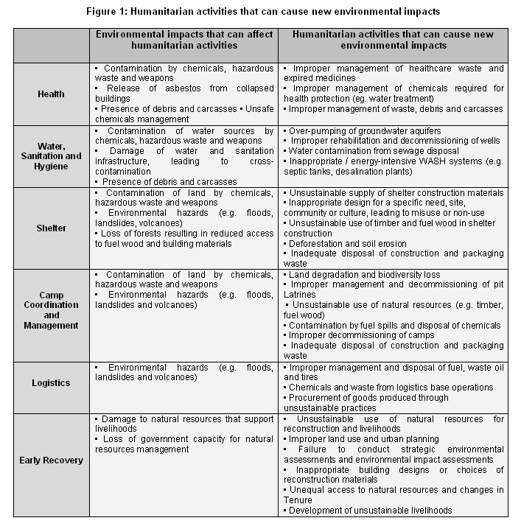
Second, in situations of mass displacement the humanitarian community often misses the opportunity to minimize the environmental impact of refugee and IDP settlements. Displacement camps are built out of short term necessity, but in practice usually endure for many years. If not well managed, competition for scarce resources around such camps, such as over water, wood and land, can create conflict drivers which hamper long term peace building efforts. In the Darfur states of western Sudan, for example, boreholes have run dry in some camps and conflict between local residents and wood gathering camp dwellers is commonplace, with large scale deforestation quite common [3]. Similarly, between 1994 and 1996, 36 million trees from the Virunga National Park in the Democratic Republic of Congo were used to meet the cooking and shelter needs of Rwandan refugees [4], at great cost to the natural environment and future sustainable development efforts.
Third, natural resources are often required to meet immediate the relief needs of affected populations following a disaster or conflict. Unfortunately, this is often achieved through intensive and rapid extraction of scarce local resources, creating new sources of risk and vulnerabilities. For example, in Afghanistan, energy and construction needs of conflict-affected populations have devastated the once grand pistachio stands that formerly provided a long term environmental investment for the population.
Finally, in the midst of a crisis, there is a common perception that natural resources and the environment represent a trivial or less pressing issue then immediate humanitarian needs. Because the practical benefits of integrating the environmentally sustainable policies and practices are not well understood by enough actors in the field and too little human capacity of the issue is in place in crisis situations, this myth too often remains unresolved. Though natural resources are often the starting point for economic and social rebuilding and environmentally sensitive recovery is vital for ensuring long term sustainable development, the marginalization of environment is widespread.

Overcoming these challenges
Some environmental challenges for humanitarian action can be solved through relatively simple and quite feasible changes to standard practice of relief and recovery operations. For instance, small operational modifications, such as the use of green procurement to minimize the long term impact of packaging or eco-friendly fleet management and driving techniques to reduce air pollution and fuel consumption, can improve the long term impact of humanitarian activities.
However, several of the challenges require a larger commitment from the humanitarian community of practice. First and foremost, changes are needed in the current operational approach for humanitarian response in order to mainstream environmental concerns. The existing modi operandi of humanitarian actors — short term, ad-hoc planning and decision making that takes place within operations with many, small financial contributions – are fundamentally counterproductive to environmental concerns, which are relevant in a broad time spectrum. To counter this, a shift in mindset and policy scope is needed, with the operating procedures of humanitarian actors and donors reacting to the needs of the medium and long term, as well as the short. Indeed, a change in the ‘way of doing business’ is needed that recognizes that human needs will continue, if not intensify, following the initial emergency phase.
Second, a significant change is also needed in the manner in which humanitarian action is financed. While the donor community acknowledges the importance of preserving the environment and using natural resources in a sustainable fashion during emergencies, too often funding structures prevent multi-annual commitment and support for mitigating activities. As noted before, taking care of the environment during relief and recovery activities is an ongoing endeavor, and an effort that provides important benefits in the long term. It is important that donors start providing funds to humanitarian actors to allow them to design their response plans in a way that greatly reduces negative impacts for the environment, and reduces the need for donors to later fund additional clean-up or reclamation activities, let alone additional crises from migration or conflict [5].
Finally, although the need to include environmental consideration in the humanitarian response has been clearly recognised by the humanitarian reform process, leading to specific guidance regarding mainstreaming, what was envisaged has mostly not materialised in practice. Environment remains marginalized in institutional planning, the implementation of needs assessments and program design and during response activities. For one, environmental concerns have been a casualty of the ongoing debate about the boundaries of “lifesaving activities,” which are the essential role of the humanitarian response. Though many humanitarian practitioners agree that contributing to livelihood revitalization and sustainability, including the environmental response upon which they rely, is a core role for early response humanitarians, others argue that any activity that falls outside a strict, historical definition of humanitarianism is inappropriate. As such, it is key that policy makers and planners within the humanitarian community aggressively tackle these contradictions, using multiple fora and by producing practical suggestions for relief actors in the field.

Action to be taken
Following consultations with cluster leads (UN) and non-UN actors and by taking into consideration the lessons learned and the recommendations provided by several studies and best practices to date [6] , UNEP intends to respond to the challenges mentioned above in a collaborative and pragmatic fashion with key partners from the humanitarian, development and environment community. A number of responses have been designed that will strengthen the capacity of the humanitarian community to react to environmental concerns and prevent relief and recovery activities from dealing environmental damage in post-crisis situations.
A. Environment Network and information sharing platform. An Environment Network at global level will serve as a community of practice and an information sharing platform. Within the network, a core group will be formed that will meet on a regular basis to identify the gaps and needs in terms of tools, guidance, training, technical support for country operations, to identify the activities needed, to share the work load to meet the needs, and to develop joint advocacy strategies. The UNEP-managed Environment Network web page for environment on the OneResponse website [7] will be accessible for the public at large as well and will be an indispensable platform for information sharing.
B. Integrating environmental needs within IASC policy and operations. In order to influence the IASC process and other relevant humanitarian policy developing processes, UNEP will (i) increase its active participation in IASC subsidiary bodies, task forces, and working groups of concern (Sub Working Group on the CAP, Task Force on Climate Change Adaption, Task Force on Needs Assessments, etc.), (ii) enhance its interaction with the other actors in the humanitarian coordination mechanism (clusters of concern and the Cluster Working Group on Early Recovery in particular, OCHA, etc.), and (iii) undertake awareness and advocacy activities targeting staff at decision making / policy level in organizations of concern, as well as donors. A cost-benefit analysis of environment in humanitarian action will support the awareness efforts.
C. Training for humanitarian actors to integrate environmental issues within their operations. Training on Mainstreaming Environment into Humanitarian Action [8] will provide capacity to UN and non-UN actors and training materials will be developed. On a needs driven basis, regional and country based trainings will be organized /to the extent possible and sector specific training modules will be derived. Modules on mainstreaming environment in humanitarian action will be integrated in humanitarian coordination trainings, early recovery advisory trainings, resident and humanitarian coordinator trainings, and trainings of other clusters of concern.Training will be developed based on mapping of existing material.
D. Tools and guidance. UNEP, with the partners on the Environment Network, will develop technical standards, and monitoring and evaluation frameworks. Based on a mapping of existing tools and guidance, new tools will be developed, adapted or standardized. Tools and guidance will be disseminated globally and will be shared through the Environment Network website [9].
E. Field deployment and real-time technical assistance. Upon request and following the necessary training, UNEP or other partners in the network will participate in inter-cluster / inter-agency needs assessment processes and provide real-time environmental advice to humanitarian agencies on minimizing environmental damage and doing no harm while meeting humanitarian needs.
F. Contribute to the sustainability of early recovery operations. With a view to ensuring the sustainability of early recovery operations, we will have to invest in enhancing the environmental response (i) at the international level, by improving communication, liaison and interaction between relevant cluster members; and (ii) at the local level by building the capacity of national experts and institutions. National strategies, local experiences and coping mechanism should be taken into account when and where appropriate. Such an approach will enhance the strengthening of institutional capacity of humanitarian and other actors concerned to mainstream environmental considerations into the development of policies, monitoring and evaluation tools and frameworks, staff training, advocacy and fundraising strategies, and, most importantly, their operations in (post)crisis situations.

Conclusions
Humanitarian action stands to benefit immensely from the effective mainstreaming of environmental considerations into crisis response, as environmental best practices provide for a smoother shift into sustainable recovery. A reduction in the negative, sometimes irreversible, impacts for the environment will contribute to a faster recovery and will be conducive to rebuilding livelihoods and the socio-economic fibre of communities, while contributing to poverty alleviation. Less soil contamination and soil degradation will allow people to restart small scale farming; more equitable management of natural resources, water, fertile soil, will contribute to better inter-community relations and will have a conflict preventing effect and enhance peace-building and reconciliation efforts . Alternative cooking and heating systems will reduce the exposure of women and children to exploitation and sexual violence: they will not have to walk for hours to collect wood in remote places and children and girls will be able to attend school more often. The mitigation of negative environmental impacts will contribute to a reduction in the institutionalisation of emergency situations and diminish the chance that groups of people find themselves in a protracted situation of dependency.
Lastly, a closer cooperation between the environmental community and humanitarian community will lead to more collaborative and coherent responses to all crises, showing solidarity with vulnerable and hurt people rather than discord and competition.
Tom Delrue is programme officer “Humanitarian Action - Early Recovery” in the Post-Conflict and Disaster Management Branch of UNEP. Renard Sexton is project advisor “Environmental Cooperation for Peacebuilding” in the same branch (see : www.unep.org/conflictsanddisasters).
[1] Code of Conduct for The International Red Cross and Red Crescent Movement and NGOs in Disaster Relief, Available Online at: http://www.ifrc.org/publicat/conduct/index.asp
[2] ‘Humanitarian Action and Environment – Essential Guidance for Humanitarian Actors’, UNEP-OCHA http://oneresponse.info/crosscutting/environment/publicdocuments/Forms/DispForm.aspx?ID=5. The leaflet includes two pages of available standards, guidance, tools and resources.
[3] For more see the UNEP Sudan Post-Conflict Environmental Assessment, Available online at : http://www.unep.org/sudan/.
[4] For more see Biswas, A. & Tortajada-Quiroz, H. (1996) Environmental impacts of the Rwandan refugees on Zaire. Ambio 25(6):403-408 and The Encyclopedia of the Earth, Virunga National Park, Democratic Republic of Congo Available online.
[5] Morton, A. and Jensen, D. ‘Managing environmental issues: a case for substantive reform, FMR, issue 29.
[6] E.g. ‘Mainstreaming the Environment into Humanitarian Response – an Exploration of Opportunities and Issues’, Environmental Resources Management Limited, November 2007, p. 27-29. http://oneresponse.info/crosscutting/environment/publicdocuments/ERM_%20Final%20Report_08%2011%2007.pdf
[7] http://oneresponse.info/crosscutting/environment/Pages/Environment.aspx
[8] Such training is currently being developed by Groupe URD and UNEP in consultation with other actors.
[9] Examples of existing tools are the ‘Environmental Needs Assessment in Post-Disaster Situations - A Practical Guide for Implementation’, UNEP, March 2008. http://oneresponse.info/crosscutting/environment/publicdocuments/UNEP_PDNA_draft.pdf and ‘PCNA-TRF Tool Kit - Note on Addressing Environmental Issues’, February 2009 http://www.undg.org/docs/9926/Final-Draft-Toolkit-Note-Environment-9-March-2009.doc

